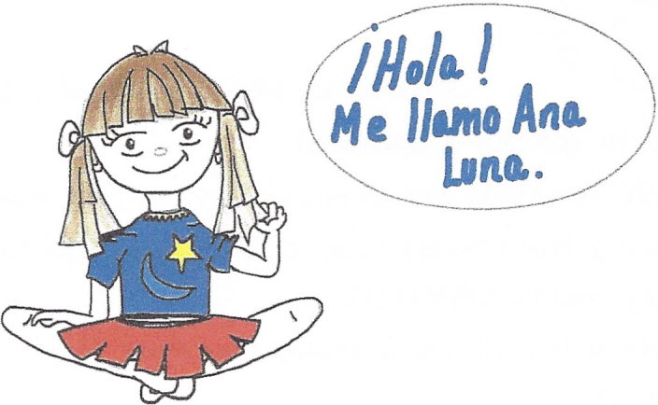
SPANISH LANGUAGE PHRASES AND QUESTIONS FOR AT HOME REVIEW AND
REINFORCEMENT.
FRASES Y PREGUNTAS EN ESPANOL PARA REVISAR Y REFORZAR EN EL HOGAR.

¿Cómo te llamas?
¿Cómo estás?
¿Cómo te sientes?
¿Cuántos años tienes?
Buenos días.
Buenas tardes.
Buenas noches.
¿En dónde vives?
¿En dónde está ...?
Estoy aquí…
Estoy en ...
Es hora de ...
¿En dónde está tu ...
¿En dónde están tus ...
¿Qué hora es?
Es hora de ir a la escuela.

What is your name?
How are you?
How do you feel?
How old are you?
Good morning.
Good afternoon.
Good night.
Where do you live?
Where is your ...?
I'm here.
I'm in ...
It's time to ...
Where is your ...
Where are your ...
What time is it?
It's time to go to school.



UNA GUIA PARA HABLAR ESPANOL

(A guide to speaking Spanish)
- SPANISH words are pronounced exactly the way they are written.
- Knowing the vowels (a,e,i,o, and u) is the secret to understanding
and speaking SPANISH.

- People will still understand you even if you don't say every word
correctly.
- Remember your SPANISH will get better only if you speak it EVERY
DAY. !!
LOS SONIDOS DEL ESPAÑOL.
The sounds of Spanish.
These are the five most important sounds of SPANISH they have very
different sound. Go ahead, say each one aloud three times.
A {like "ah”) the doctor tells the boy to say "ah"
E (like "eh") when you can't hear welt you say "eh"
I (like "ee") the girl who is scared says "ee"
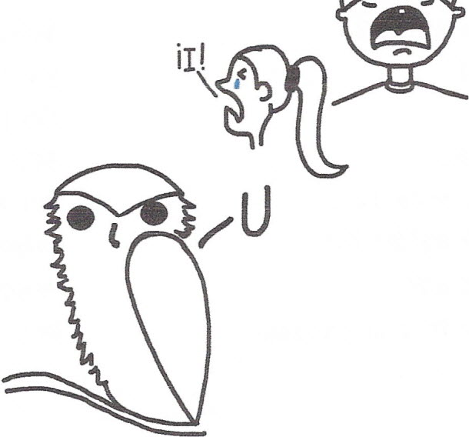 o (like "oh") when you get a surprise you say "oh" / A U (like “oo”) the owl says "00"



¡E!
 ¡O!

